

**NCRD’S STERLING INSTITUTE OF MANAGEMENT STUDIES**

**NERUL, NAVI MUMBAI**

**MASTER OF COMPUTER APPLICATION**

**Semester II**

**UNIVERSITY OF MUMBAI**

**Our Project**

**MUSIC WEB DESIGN**

**Group Members**

**Kartik Chopade- 06**

**Ajit Gupta - 18**

**Bhushan Gawade - 15**

|  |  |  |
| --- | --- | --- |
| **SR NO** | **Name Of The Experiment** | **Date** |
| **1.** | **Introduction to UI life cycle and UI tools** | **21/05/21** |
| **2.** | **Project Proposal and Requirement Gathering (**Introduction Of Project) | **04/06/21** |
| **3.** | **Logo Designing** | **04/06/21** |
| **4.** | **Problem Statement: System Concept Statement** | **11/06/21** |
| **5.** | **Design a persona.** | **18/06/21** |
| **6.** | **Customer Journey Map** | **18/06/21** |
| **7.** | **Entity-Relationship diagram.** | **25/06/21** |
| **8.** | **Creation of Scenario- Story Board** | **02/07/21** |
| **9.** | **Create Wire framing** | **09/07/21** |
| **10.** | **Create  Prototype** | **16/07/21** |
| **11.** | **Usability Evaluation of the Design**  **Testing of User Interface from Third Party(Test scripts)** | **23/07/21** |

**INDEX**

**Introduction to UI life cycle and UI tools**

**UI Life Cycle:**

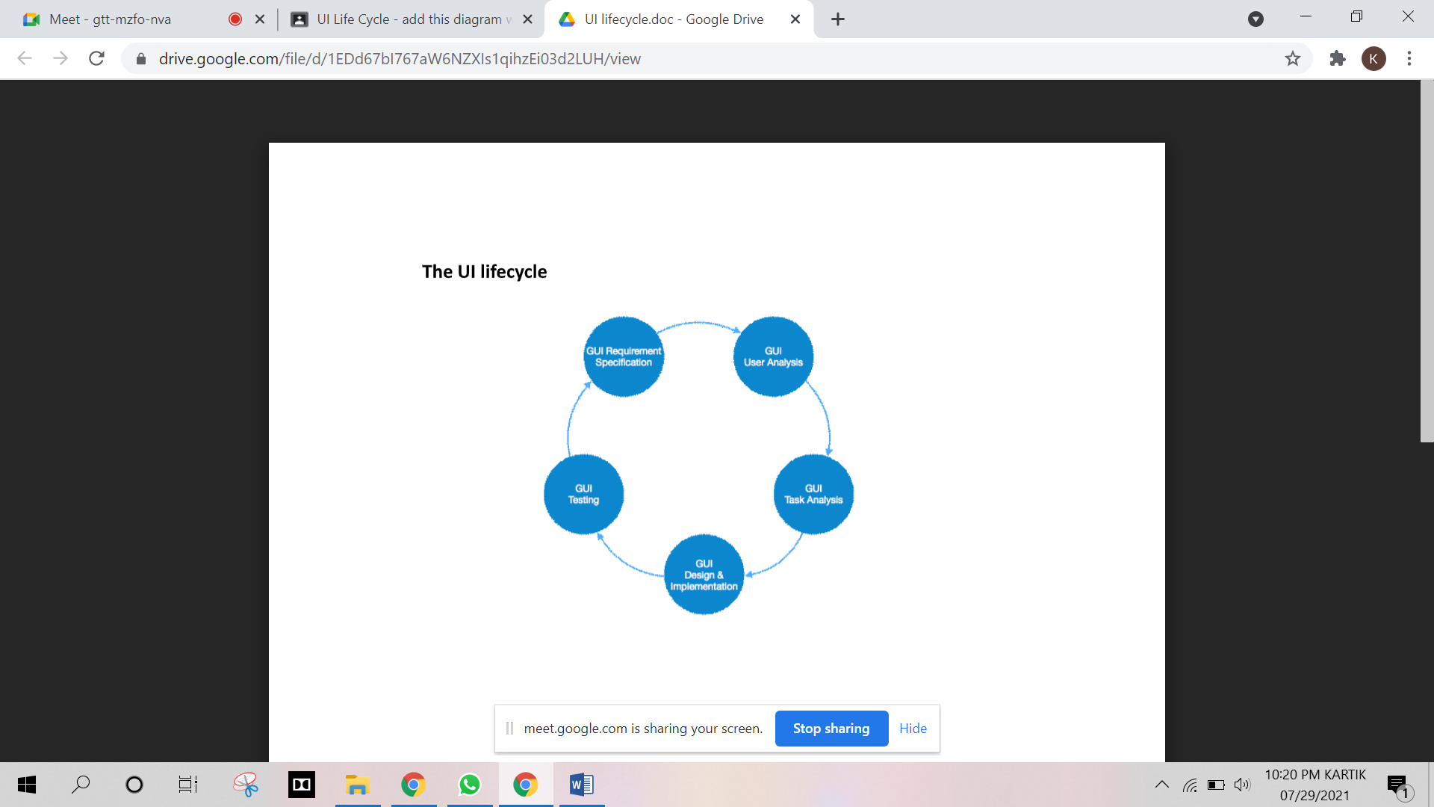

**UI tools:**

**1. Set up your Figma account**

Getting started in Figma is as simple as going to [www.figma.com](http://www.figma.com/), clicking “Sign up”, and entering your details. Once you’ve done that, Figma will open up with a start screen like this. Click on “New File” and we’ll get started!

**2. Take a look around the Figma interface**

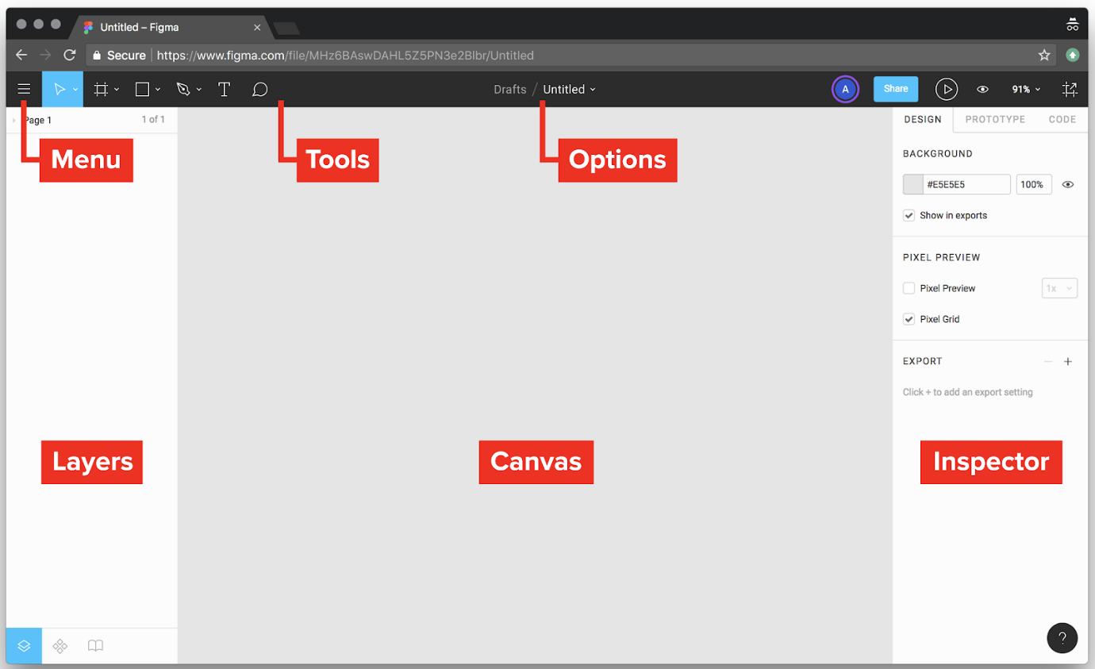

The look and feel of the Figma interface is quite minimal, but it belies a set of powerful features. Here’s an explanation of the interface’s main areas (labeled above):

**Menu:**

Unlike regular desktop design apps, Figma’s menus can be found by clicking the hamburger button in the top-left of the screen. Take a minute to browse around these menus and see what’s there! You can also search for the specific command you need. Start typing in “rectangle” and you’ll quickly find the Rectangle Tool, complete with a handy reminder of its keyboard shortcut (it’s R, by the way).

**Tools:**

Here you can quickly access the tools you’re likely to use most often: frames, shapes, text, etc. (We’ll cover all these tools in the next couple of days!)

**Options:**

This area shows extra options for whichever tool you have selected. When no object is selected (as shown above), Figma displays the file name. When an object is selected, contextual options appear here.

**Layers:**

Where every element in the file is listed, organized into Frames and Groups.

**Canvas:**

This is where you create and review all your work.

**Inspector:**

The Inspector shows contextual information and settings for whatever object is selected. In the image above, we’re seeing options for the Canvas itself. Note that Figma gives us separate tabs in the Inspector (Design, Prototype, and Code)—we’ll cover these later in the week.

Now that you’ve found your way around, let’s start making stuff! Note that we’ll be referring to keyboard shortcuts a lot in these tutorials. It’s worth getting in the habit of using these shortcuts right from the off, because they’ll significantly speed up your workflow further down the line.

**3. Create a Frame**

In Figma, a Frame is essentially a container for other elements. If you’ve used Sketch or Adobe Illustrator before, it functions in the same way as an Artboard. Press F to select the Frame Tool. Alternatively, you can click the Frame Tool icon in the Options panel at the top of the window. Equally, if you’re used to Sketch, you can also hit A(for “Artboard”).

There are a couple of ways of creating a Frame. We can either click and drag in the canvas area, or we can select a pre-set Frame size from the Inspector on the right hand side of the window. Try both ways now!

**4. Practise zooming in and out**

You’ll probably find yourself wanting to zoom in and out quite a bit in Figma, particularly once we start working with multiple Frames. The standard zoom commands are accessed with ⌘+ and ⌘-. Try it now!

Those commands will just focus in on the center of your current view. But there are some other handy zoom commands available:

* Shift ⇧2 will zoom to the current selection
* Shift ⇧1 will zoom to show the whole canvas

Select the Frame by clicking on its name, then try alternating these commands to switch between the selection and the whole canvas.

Finally, here’s an *extra* handy zoom tip to move between Frames without having to zoom in and out the whole time:

* N will zoom to the next Frame
* Shift ⇧N will zoom to the previous Frame

**5. Practise using the hand tool to move around the canvas**

Another useful tool, particularly when you’re zoomed in close or working on a large file, is the Hand tool. Try pressing spacebar and you’ll see a hand icon pop up. Click and drag to move the whole canvas around. If you’re working with a Mac trackpad, you can do the same by dragging on the trackpad with two fingers.

**6. Create a Text layer**

Next, let’s create some text. Press T to select the Text tool, and click anywhere within your iPhone 8 frame to create a Text layer. This is going to be part of a button design, so let’s type “Sign In”. Hit Escape to exit the Text tool.

**7. Create a rectangle and arrange the layers**

Press R to select the Rectangle tool. Drag a button-shaped rectangle around the text you just created.

Currently, the text is hidden underneath the rectangle. To fix this, we need to use Figma’s “Arrange” commands. Head over to the Layers panel on the left of the window. Select the “Sign In” text layer, then right-click (PC/Mac) or ctrl-click (Mac) to bring up a list of options. Click “Bring to front”, and the text will now be placed on top of the rectangle.

You can also access Arrange tools using keyboard shortcuts:

PC:

* Ctrl]: bring forward
* CtrlShift ⇧]: bring to front
* Ctrl[: send backward
* CtrlShift ⇧[: send to back

**8. Align the text and rectangle**

This being a button, we want the text and rectangle shapes to be centered relative to one another. Figma has a set of “Align” commands that allow us to do this. Make sure that the Move tool is selected by pressing Escape, or V, and then drag a “marquee” (a rectangular selection) around the text and the rectangle.

This time, we can access the Align commands in the Inspector (the interface area to the right of the window). Click “Align Horizontal Centers” and “Align Vertical Centers” to get the two objects nicely lined up.

**9. Add rounded corners to the rectangle, and change the color**

Select the rectangle shape you just created. In the Inspector, there is a setting called “Corner Radius”, which allows us to make the corners of any shape rounded. Here, type in the number of pixels you want each corner be rounded by.

To max out the corners and create semi-circles at each end of the rectangle, just enter a number larger than half the object height. (We set ours to 32 so that we’re covered in case we want to make the button a bit bigger later on—but try out some different numbers and see what happens!)

The color settings can also be found in the Inspector. We often want to attract people’s attention with buttons—so select the rectangle, and pick a bright color! We’ve gone with a bright yellow by typing in a hex code (#EEEE33)—but you can also click to open the color palette, and pick a color that way.

**10. Change the font**

With the text layer selected, you can access settings in the Inspector to change the font, as well as font size, weight, and color. We’ve stuck with Roboto, but switched up to bold and uppercase text. Try exploring the options!

**1. Open up your Figma file, and create the Frame for your app screen.**

First things first—open up the same Figma file you were working on yesterday. (It should show up in the “Recent” tab on the Figma home screen.)

Just like we did yesterday, hit F to select the Frame tool, and pick iPhone 8 from the options on the right of the window. Then let’s set a background color for this screen. With the new Frame selected, look over to the Inspector on the right of the Figma window. Click the white square under where it says “Background”, and choose a color. We’ve gone for #2F80ED, which is the shade of blue in the bottom-left of Figma’s default color swatches.

**2. Add a column grid**

It’s important to work using a column grid, even when we’re designing for mobile. Doing this means that we make positive decisions about spacing and layout—for example, the amount of space we leave between elements and the edge of the screen.

In Figma, it’s super easy to add a column grid. With the Frame selected, simply click the “+” icon in the Inspector under where it says “Layout Grid”.

* Count: 3 (this creates 3 columns)
* Gutter: 16 (this adds 16 pixels of space between each column)
* Margin: 16 (this adds 16 pixels of space at the edges of the Frame)

**3. Add the name of your app**

Let’s create a simple “wordmark” using the Text tool. A wordmark is basically the name of a company or product set in a beautiful way using text only. Press T to select the Text tool, then click in the frame and type out your app’s name. We’ve set ours all lowercase in Roboto Bold, text size 42 pixels, and set the text to be white (#FFFFFF).

**4. Reposition the wordmark**

If you click and drag on the text you’ve just created, you can move it around the frame to reposition it. You’ll notice if you drag it near the horizontal middle of the frame, guides will pop up to indicate that the text is centered. Once it’s centered, release the mouse button!

**5. Create the username field**

We can easily create some sleek login fields just using rectangles and text. First, select the Rectangle tool R and click and drag to create a rectangle about 250 pixels wide and about 30 pixels high. Notice how Figma displays the size of the shape in numbers as you’re drawing it?

Change the fill color to be white (#FFFFFF). We then need to change the Opacity setting to make the shape semi-transparent. This isn’t actually labeled in the Figma interface, but it does exist: it’s the number shown in the Inspector under “Layer”. It’s set to 100% by default—let’s change that to 25%. You can also set this by simply selecting the object and typing in the opacity value you want. Try it—select the rectangle and simply type “25”. (This is strangely satisfying, you’ll agree.)

Next, press T to go back to the Text tool. Click anywhere in the frame, and type “Username”. The font will probably still be set to the size you just used for the wordmark, so once you’ve typed the text, select the Text layer and change the text size to 16 pixels. Change the font color to white, and again change the opacity—this time let’s go for 70%. Drag the text label over the rectangle. Hey presto! A form field.

As a final step, make sure that the “Username” text is positioned nicely in relation to the rectangle. You can do this by clicking once on the text layer, and then “nudging” it 1 pixel at a time using the arrow keys. If you hold down Shift ⇧ while using the arrow keys, the selection will move in 10 pixel increments.

**6. Duplicate the username field to create a password field**

It’s very easy to duplicate elements in Figma. With the Move tool selected V, just drag a marquee (rectangular selection) around the rectangle and text you just created. You can use old-school copy and paste (CtrlC then CtrlV on PC).

Alternatively, you can hold down  Alt (PC), and then click and drag from the selection to make a duplicate.

Place your duplicate objects so that they’re sat directly below the username field. Then, simply double-click the “Username” text and change it to “Password”.

**7. Duplicate the button you made yesterday.**

Another way to duplicate elements is by selecting them and hitting  CtrlD (PC). Try this with the button you created yesterday. The duplicate will be placed directly on top of the original—so once you’ve created the copy, just drag it across to the other frame. This shows how easy it is to move elements between frames in Figma—it’s a simple drag and drop.

**8. Make a more interesting background**

In Figma, we can only apply flat colors as Frame backgrounds. To do something more exciting, let’s draw a Rectangle R the same size as the Frame. Just click in the top-left and drag down to the bottom-right: Figma will try to snap the shape to the edges of the Frame, but if it’s not quite right, you can always use the resizing handles to tweak it.

Once we’ve made the rectangle, the first thing to do is to send this huge new shape behind the other elements in the Frame. With the rectangle still selected, press ⌘Option[ (Mac) or CtrlAlt[ (PC) to send the shape to the back.

Next, click the Fill color in the Inspector, and click where it says “Solid” in the top-left of the color panel. Choose “Linear” to apply a linear gradient. Pick a color that you think transitions nicely into the background color for the frame. Creative! We’ve gone for a pinky-gray (#E36FA6).

**9. Lock the background layer**

When we create a background layer like this, we’ll often want to lock it so that it doesn’t accidentally get selected every time we try to create or edit other objects. To lock that background rectangle, hover over it in the Layers list (on the left of the window), and click the open padlock. If you ever want to unlock it, you just go back over and click the padlock again.

You can also lock and unlock layers with the keyboard shortcut ⌘Shift ⇧L(Mac) or CtrlShift ⇧L (PC). Or, indeed, right click (Mac+PC) or Ctrl + click (Mac) and select the lock/unlock option from the menu that pops up.

**10. Align & refine the layout**

The last thing to do today is to make sure that everything is nicely aligned. Here are some things to check:

* Is the “Username” and “Password” text beautifully positioned relative to the rectangles behind the text?
* Do those rectangles line up perfectly with the grid columns?
* Are all the screen elements centered?

We also made some other refinements at this stage too: we changed the background color of the “Sign in” button to be white, and made the button a bit wider so that it occupied a whole column of the grid. We also made the app name a bit bigger, and changed the vertical position of elements until things were looking balanced:

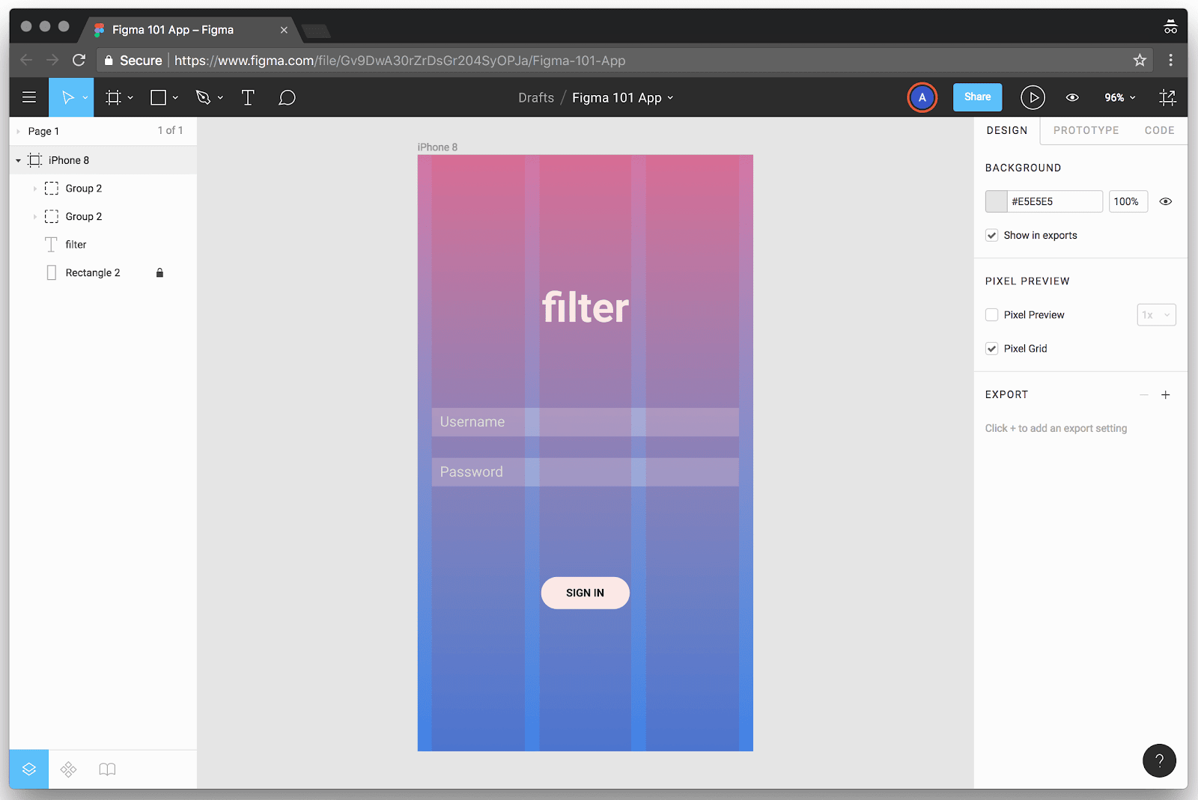

You can access this command through the menu (File > Save to Version History), or by pressing  CtrlAltS (PC).

Completing this step means we can easily look back at the changes we made each day, and even revert to an earlier version if we want to

**1. Open up your Figma file, and create a new Frame**

Just like yesterday, let’s open up the same file in Figma and add today’s work to it. Generally it makes sense to keep all of the work for a project in a single file, because it allows us to easily move and duplicate elements between Frames. As we’ll see on Day 5, it’s also crucial when it comes to creating app prototypes.

For today, though, let’s hit F and create a new iPhone 8 frame. We’re not going to make the next app screens until tomorrow, but today we’ll use this blank Frame to create our logo and icons in.

**2. Draw a rectangle for the camera body**

Inspired by Instagram’s logo, let’s create a little camera logo just using shapes. This is as simple as stacking a couple of circles on top of a rectangle. First, press R, and drag a rectangle 64 pixels by 64 pixels. If the size isn’t quite right, you can tweak it by changing the size values in the Inspector to the right of the window, or by resizing the rectangle using the resize handles.

**3. Round the corners of the rectangle**

Next, round the corners of the rectangle just like we did on Day 1 when we made our button. This time, set the corner radius to be 8 pixels.

**4. Draw a circle for the camera lens**

Then, press O to select the ellipse (circle/oval) tool. Click and drag to create a circle that’s 32 pixels by 32 pixels. You can hold down Shift ⇧ while doing this to “constrain” the shape—meaning that that height and width stay the same. Set it to have a white fill color so that we can see it on top of the rectangle.

**5. Align the two shapes horizontally and vertically**

Click and drag a marquee around the two shapes you just made, and then click the “Align Horizontal Centers” and “Align Vertical Centers” buttons at the top of the Inspector.

**6. Create another circle for the light meter**

Finally, create another circle, this time 8 pixels by 8 pixels, and set that to have a white fill too. Position it so that it’s at the top-right of the rectangle shape (4 pixels from the top and 4 pixels from the right). Pro tip: you can check the position of any shape relative to another shape by selecting it, holding down Option (Mac) or Alt (PC), and hovering over a second shape.

**7. Use “Boolean operations” to turn the camera into a single shape**

There’s a group of commands in Figma called “Boolean operations”. These allow you to take two or more shapes and unite them into a single shape, or subtract one shape from the other, or even isolate where the shapes overlap.

For our camera logo design, let’s click and drag to select all of the three shapes we just created—the rounded rectangle and the two circles. Then, click the tiny arrow next to the “Boolean Groups” icon at the top of the interface, and select “Subtract Selection”:

Finally, use the Flatten command to convert the camera into a single vector object. With the logo selected, hit ⌘E (Mac) or CtrlE (PC). Doing this means that the shape will resize correctly.

**8. Create a 3D box using the Pen tool**

So far today we’ve created a logo just using shapes and Boolean operations. But we can also draw using the pen tool—and in Figma, the pen tool has superpowers, aka “vector networks”. To understand what vector networks are, here’s a bit of background info.

In most graphics applications, including Photoshop, Illustrator, and Sketch, there is a Pen tool (sometimes called the Vector tool). The Pen tool is usually viewed with suspicion by new users, because it can been quite unintuitive to use.

One of the reasons for this is that in these other packages, the pen tool is entirely linear: the points in a shape could only be connected A to B to C to D, and so forth. Paths could be “closed” by being joined back up to their starting point, but that was it.

Figma has redesigned the Pen tool to add “vector network” functionality. This means that a single point can now be connected to any number of other points. Also, when it comes to setting a fill color for a vector shape, you can choose which of the enclosed areas within the shape the fill will apply to.

As an example, here’s how we went about drawing a 3D box using vector networks. We recommend turning on Pixel Grid— ⌘' on Mac, or Ctrl' on PC—and adding a square-based Layout Grid to the Frame, so that you have a visual guide for how to place and align your points.

Notice how, once we’d completed the first enclosed space, we had to select a previously created point to tell Figma which point we want the next point to connect to. If in doubt, just click an existing point, and that will define the connection for the next point you add. Now try it yourself!

**9. Create a set of icons**

Once you’ve experimented a little with vector networks by drawing that 3D box, let’s go ahead and create a simple icon set! Using the vector network functionality, draw an envelope icon, a home icon, and a back arrow.

**Note:** because points don’t *have* to be connected to one another in Figma’s Pen tool, it’s easy to accidentally create multiple shapes within the same vector element. So once you’ve completed one icon, make sure to exit that shape by click “Done” in the Options panel at the top of the interface. You can then re-select the Pen tool and start on the next icon.

Here are our tries at those three icons:

**10. Practice editing, moving, or aligning the points within shapes**

Note that currently Figma doesn’t give you *too* much help when it comes to aligning and positioning your points. But if you select the Move tool V and double-click any shape you’ve made, you can move the points around, and even use the alignment and distribution commands at the top of the Inspector to line things up. Try it out!

**Project Proposal and Requirement Gathering (Introduction Of Project)**

The “Online Music Web” has been developed to override the problems prevalling in the practicing manual system. This software is supported to eliminate and in some cases reduce the hardships faced by this existing system. Moreover this system is designed for the particular need of the company to carry out operation in a smooth and effective manner.

The application is reduced as much as possible to avoid errors while entering the data. It also provides error message while entering invalid data. No formal knowledge is needed for the user to use this system. Thus by this all it proves it is user-friendly. Online Music Portal, as described above, can lead to error free, secure, reliable and fast management system. It can assist the user to concentrate on their other activates rather to concentrate on the record keeping.

Every organization, whether big or small, has challenges to overcome and managing the information off of Album, Music, Track, Customer, Album Type. Every Online Music Portal has a different Music needs, therefore we Vedas and exclusive employee management system that are adopted to your manage requirements. Online Music Portal and described above can lead to error free secure and reliable fast management system. The main objective of the project is to manage the detail of music album per former track album type b manages all the information about music customer album type music.

* System needs stored information about of new entry of new music.
* System need to main quantity record.
* System need to keep the record of performer.
* System need to update and delete music.
* System also need a search area.

**Logo Designing**

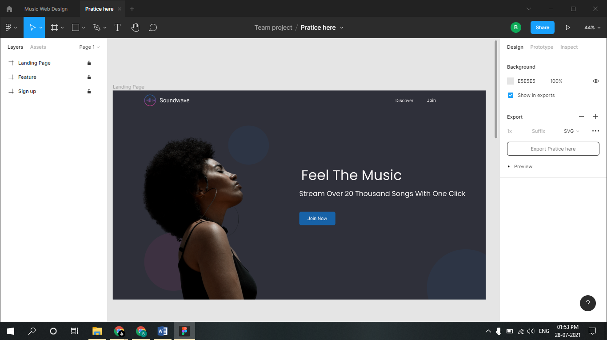

**Problem Statement: System Concept Statement**

**Problem Statement:**

From records, to cassette tapes, to CDs, methods of music consumption have evolved vastly and continue to do so today. Undoubtedly, music streaming is the future of music consumption with countless different companies currently offering their streaming services in a variety of different manners. According to Nielsen’s 2015 year-end Music report, streaming services doubled since 2014 to an astounding 317 billion streams. Music streaming allows listeners to listen to their favourite songs on demand, discover new music, create and consume playlists, on and on. Still, for all the good that comes from music streaming, there are many problems that also arise.

**CLIENT:**

Users can browse music store based on their interest. Online website provides user’s detailed information about a music album, for example singers name, director, lyrics, popularity etc.

**ADMINISTRATIVE USER CAN PERFORM FOLLOWING FUNCTIONS:**

Administrator of this website can maintain online music store website using a control panel. Add/Update music album, uploading of album thumbnail image and media files, managing various music categories

**SYSTEM CONCEPT STATEMENT:**

Objective of this project is to create a website which can host online music store and provide user’s quality music online. As internet is getting popular, this website provides online music store which can be accessed from anywhere, anytime Admin can perform following functions: Add/Update music album, uploading of album thumbnail image and media files, managing various music categories. Online users can browse music store based on their interest. Online website provides user’s detailed information about a music album, for example singers name, director, lyrics, popularity etc. User can subscribe to this website to play or download music online.

**Design a persona**

**Persona:**

The purpose of personas is to create reliable and realistic representations of your key audience segments for reference. These representations should be based on qualitative and some quantitative user research and web analytics. Remember, your personas are only as good as the research behind them

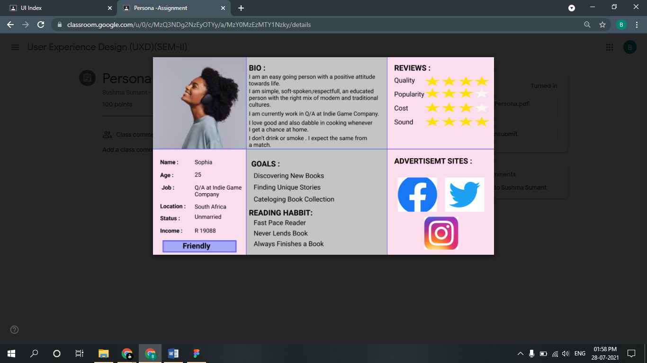

**Customer Journey Map**

**Definition:**

 A journey map is a visualization of the process that a person goes through in order to accomplish a goal. In its most basic form, journey mapping starts by compiling a series of user actions into a timeline. Next, the timeline is fleshed out with user thoughts and emotions in order to create a narrative. This narrative is condensed and polished, ultimately leading to a visualization.

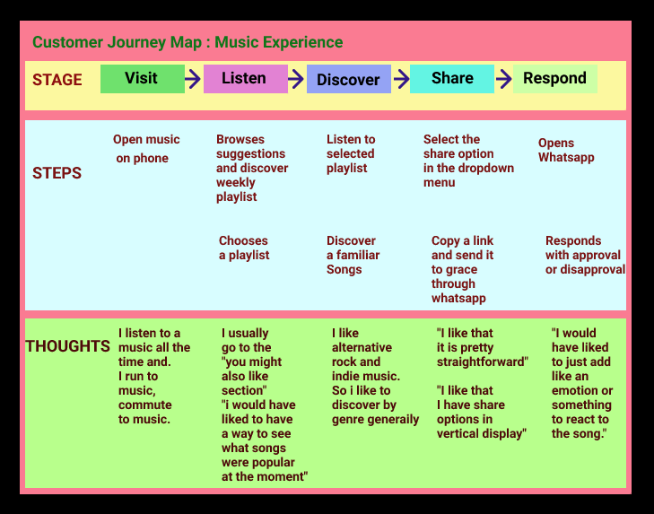

**Entity-Relationship diagram**

**ER Description:**

Login have an attribute Username, Email id and Password. User have an attribute Profile. Downloaded music have an attribute Free downloaded and Music in devices. Discover music have an attribute Artist, Song and Album.  User can login.

User search one or more discover music.

User Plays one or more from discover music.

One User can search many discover music.

One User can plays many songs from discover music.

**ER Diagram:**

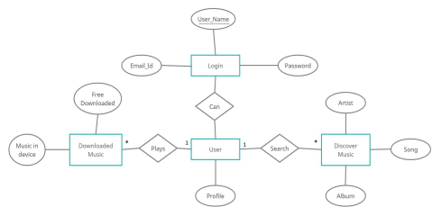

**Creation of Scenario- Story Board**

**Story Board:**

Animators and filmmakers first used the method of storyboarding. It pre-visualizes a motion picture or interactive media sequence. Walt Disney Productions developed the process itself in the early 1930s.The word “storyboard” comes from pinning the images of the story to a board. It allows for easy changes to the individual images and shots during the filmmaking process.

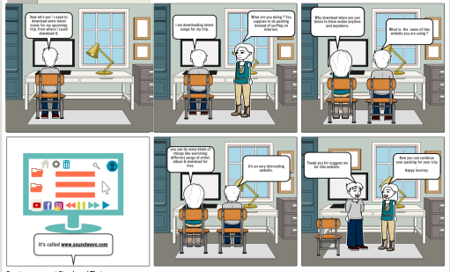

**Wire framing**

**Wire framing:**

Wire framing is a way to design a website service at the structural level. A wireframe is commonly used to layout content and functionality on a page which takes into account user needs and user journeys. Wireframes are used early in the development process to establish the basic structure of a page before visual design and content is added.

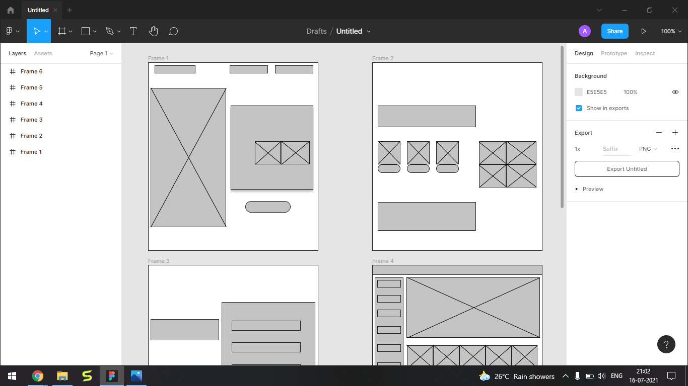

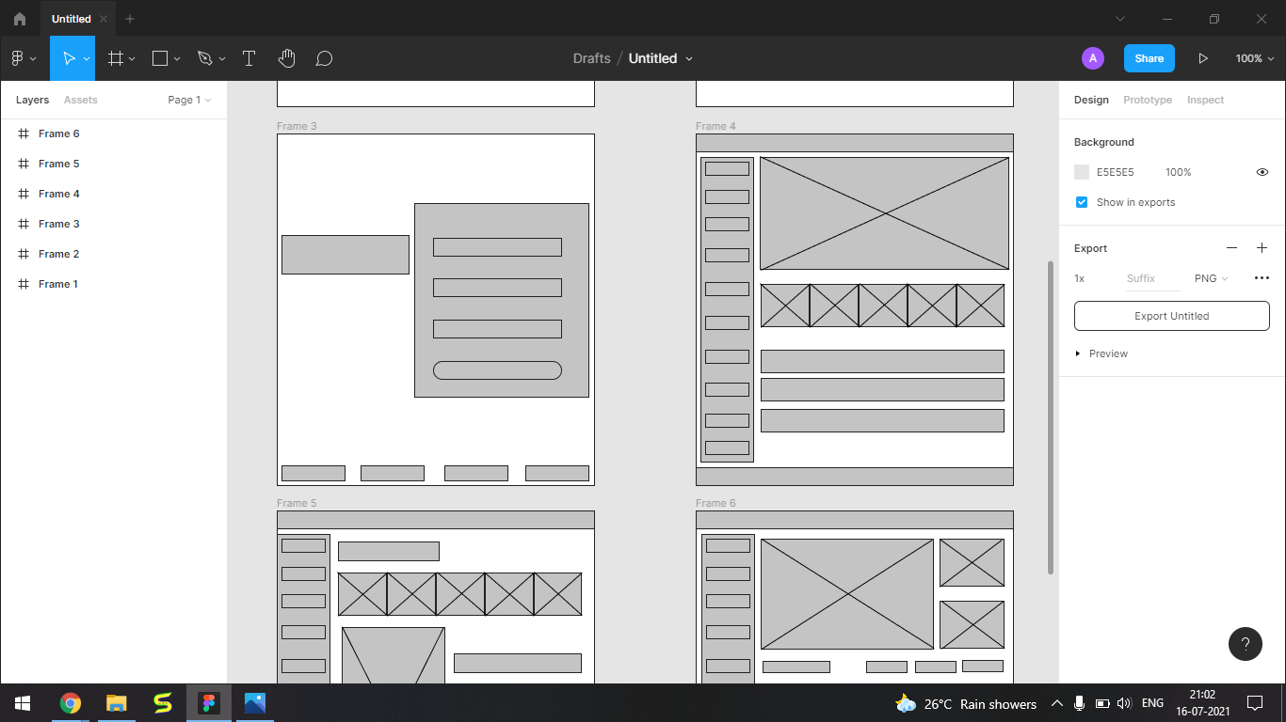

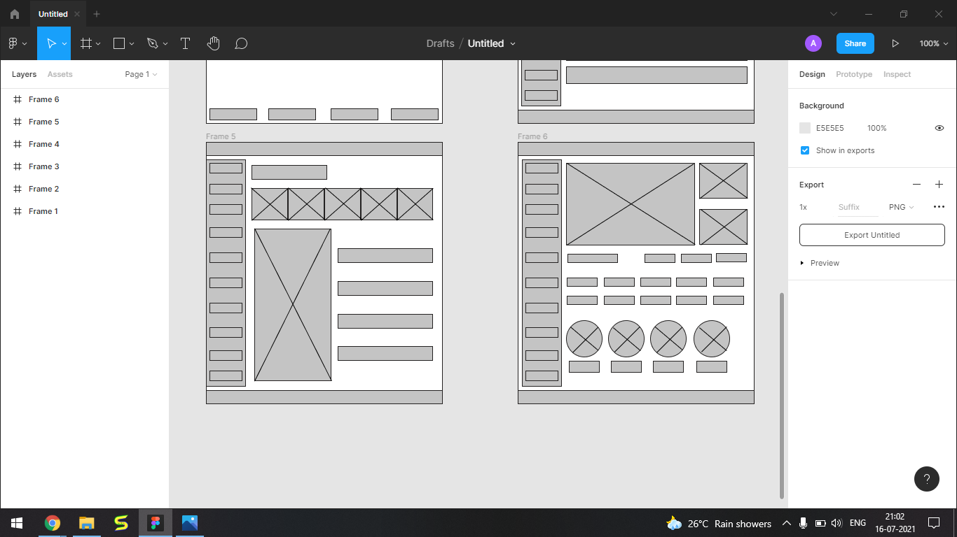

**Prototype**

**Prototype:**

Prototyping is an experimental process where design teams implement ideas into tangible forms from paper to digital. Teams build prototypes of varying degrees of fidelity to capture design concepts and test on users. With prototypes, you can refine and validate your designs so your brand can release the right products.

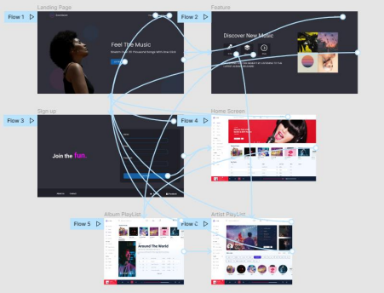

**Usability Evaluation of the Design**

**Testing of User Interface from Third Party (Test scripts)**

**Test Cases:**

A test case is a specification of the inputs, execution conditions, testing procedure, and expected results that define a single test to be executed to achieve a particular [software testing](https://en.wikipedia.org/wiki/Software_testing) objective, such as to exercise a particular program path or to verify compliance with a specific requirement. Test cases underlie testing that is methodical rather than haphazard. A battery of test cases can be built to produce the desired coverage of the software being tested.

